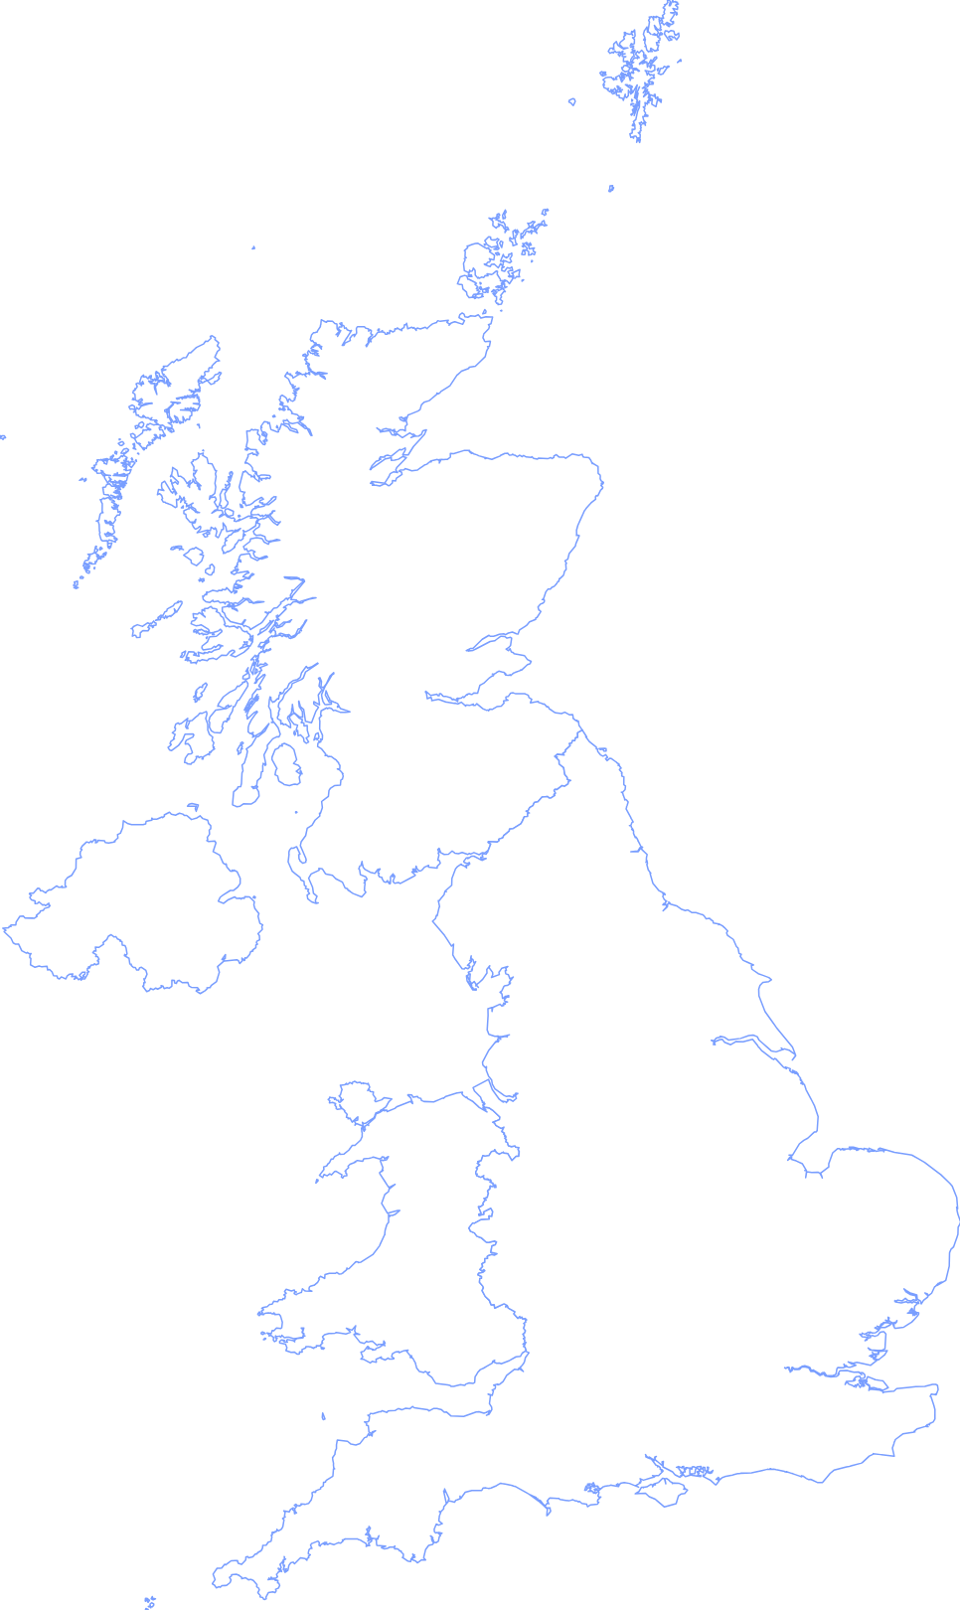

**Kynance Cove**, Cornwall

**Meon Valley Trail**, Hampshire

**Boxhill Stepping** Stones, Surrey

**Richmond Park,** London

**Dunstable Downs,** Bedfordshire

**Symonds Yat Rock,** Gloucestershire

**Chesil Beach**,

Dorset

**Snowdon Summit**

**Newborough Beach**, Anglesey

**Hardcastle Crags,**

Yorkshire Dales

**Arthur’s Seat,** Edinburgh

Top 20 romantic walks from Ordnance Survey

**White Horse Hill**,

Oxfordshire

**Kingsford Forest Park,** Worcestershire

Walsingham, Norfolk

**Llyn y Fan Fach**,

Brecon Beacons

**Sycamore Gap,**

Northumberland

**Low Fell /**

**Darling Fell**,

Cumbria

**Glencoe Lochan,** Highlands

**Coral Beach &**

**Loch Coruisk,**

Isle of Skye

**Chatsworth,**

Derbyshire